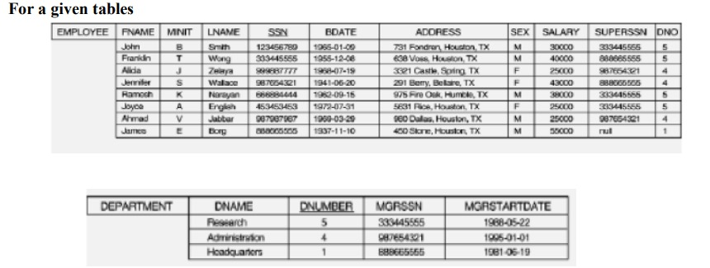

**Exp No: 21**

Create tables and perform the following

1. How the resulting salaries if every employee working on the ‘Research’ Departments is

given a 10 percent raise.

2. Find the sum of the salaries of all employees of the ‘Accounts’ department, as well as the

maximum salary, the minimum salary, and the average salary in this department

3. Retrieve the name of each employee Controlled by department number 5 (use EXISTS

operator).

**Exp No:22**

Using the same table

4. Retrieve the name of each dept and number of employees working in each department

which has at least 2 employees

5. Retrieve the name of employees who born in the year 1990’s

6. Retrieve the name of employees and their dept name (using JOIN)